TALES OF TINMOUTH

January 2017 Tinmouth

Vol. 31 Number 1 Vermont

**Editors’ Notes:** The deadline for submissions is the 20th of the month, for publication on the 1st of the following month. Please email your information to *Tales of Tinmouth* (tinmouthtales@gmail.com) or drop it off at the Town Office. Any submissions missing the cutoff date may be included in the following month.

This is the time of the year to remind those who enjoy receiving *Tales of Tinmouth* that we depend on your financial generosity to fund the printing and mailing of the monthly newsletter. Please contact volunteers Pat Psholka, Sherry Johnson or Helen Mango or drop by the Town office for details. Thank you for your support. At this time we would also like to ask those who do not wish to continue receiving *Tales* to let us know. We will be revising the mailing list soon.

*Pat Psholka, Helen Mango, Sherry Johnson*

**~ Town Meeting 2017 ~**

Thinking about serving your community? Town Meeting will find voters choosing the following officers:

*2017 Officers to be elected:*

Moderator - Town - 1 year term

Select Board Member - 3 year term

Town Clerk – 3 year term

Town Treasurer – 3 year term

Lister - 3 year term

Auditor - 3 year term

1st Constable - 2 year term

Town Agent - 1 year term

Grand Juror - 1 year term

Tax Collector (Delinquent) - 1 year term

Town Meeting is **Saturday, March 4th** this year. Public questions and budgets will be voted from the floor at the Community Center. Officers will be chosen on **Tuesday, March 7th** via Australian balloting, or you may cast an early/absentee ballot for that election.

If you wish to run for office, you must file a petition with the town clerk with **five** voters’ signatures by 5:00 PM Monday, **January 30**th. Petitions are available at the town office. Candidates must also sign a consent form.

Petitions for Articles to be placed on the warning are due by 5:00 pm **Monday, January 23rd**. 5% of voters (21 voters) must sign the petition. Voters must be registered to vote in Tinmouth.

**~ Legislative Contact Info ~**

The Vermont General Assembly will soon be back in session. If you wish to contact your State Senators or Representatives, here is the info:

You can call the Sergeant-at-Arms at 1-800-322-5616 and leave a message, or email addresses below.

Rep. David Potter: 438-5385, or 642 East Tinmouth Rd, West Rutland, VT 05777 or

email [dpotter@leg.state.vt.us](mailto:dpotter@leg.state.vt.us).

Rep. Tom Burditt: [tburditt@leg.state.vt.us](mailto:tburditt@leg.state.vt.us)

Rep. Robin Chesnut-Tangerman: [rchesnut-tangerman@leg.state.vt.us](mailto:rchesnt-tangerman@leg.state.vt.us)

Sen. Peg Flory: pflory@leg.state.vt.us

Sen. Kevin Mullin: kjmbjm@aol.com

Sen. Brian Collamore: [bcollamore@leg.state.vt.us](mailto:bcollamore@leg.state.vt.us)

You can also access the Legislature’s website at [www.leg.state.vt.us](http://www.leg.state.vt.us). There you can find who is on which committee, what bills have been introduced, track each bill’s progress, review committee agendas, etc. There is a wealth of information available.

Your input can be important in their decision-making.

**Kudos and Appreciations**

Thank you to **Hyde Ryan**, **Ali Jenkins**, and **Jonathan Jenkins** for the lovely wreath given to the Town Office/Library in memory of **Bill Jenkins Sr., Bill Jenkins Jr.** and **Mary Jenkins Wastcoat.**

Welcome to Tinmouth’s newest members, twins **Bryce** and **Rylie Duprey**, son and daughter of **Leslie** and **Kevin Duprey**, born on Christmas Day!

The Christmas Eve Service was a splendid performance! The choir nearly twenty strong, four violinists, soloists, bell ringers, flutist, pianist/organist and mastermind Rob Noble, and Pastor Shirley Oskamp, all outdid themselves with talent and spirit. Every seat was filled, and a few chairs besides as folks listened to the Christmas story and were enchanted by the candlelight ending. Thank you all!



**January 2017 Calendar of Events**

**Fire Dept Thursday 5th 7:00 Fire House**

**Library Saturday 7th 9-12 a.m. Open**

**Writers’ Group Sunday 8th 1:30 Library**

**Select Board Thursday 12th 7:00 Town Office**

**Planning Commission Monday 16th 7:30 Town Office**

**Tales of Tinmouth Deadline Friday 20th Don’t Miss It!**

**Contra Dance Friday 20th 8:00 Community Center**

**Article Petitions Due Monday 23rd 5:00 Town Office**

**Conservation Committee Monday 23rd 6:30 Wallingford Town Hall**

**THGS Sunday 29th 2:00 Town Office**

**Officer Petitions Due Monday 30th 5:00 Town Office**

### Sunday Church Service 9:00 AM ~ *All are welcome!*

### *Transfer Station hours are Wednesday 4:00 - 7:00 pm & Saturday 8:00 am - noon.*

**Library Hours** ~ **Monday 9:30-noon & 1-5** and **Thursday 9:30-noon**

***Fun “non-competitive” Volleyball on Tuesday evenings at 7:00 pm.***

**Kripalu Yoga, Wednesday 5:30-7:00 pm $10 per class Bess Lewis, Instructor, Community Center**



Seasonal camp for $129,900 sale with two bedrooms on .28 surveyed acres with 53' of lake frontage and dock on a private road at Chipman Lake. There is no public access to this a private, quiet 79-acre lake. One bathroom with shower, living and kitchen combo, two bedrooms and storage shed, gas grill, propane stove and electric refrigerator; septic and filtered lake water. Move-in condition. Being sold furnished, including a paddleboat, two kayaks and life jackets. Great view of the lake from a 10' x 35' porch. Road plowed year round for winter use - great ice fishing. Motor boats allowed. Call Larry at 802-446-2902.

**(BONUS: If you find us the person that buys our camp, we’ll pay you $1,000.)**

**Kudos and Thank You** to the many elves who worked (shopping for food, shopping for gifts, wrapping gifts, sorting food, packing boxes, donations of food, donations of $'s, donations of time, making cookies, sweet breads, nut butter, set-up and clean-up) to share the Christmas spirit with 30 families who received food baskets (3 or 4 boxes of food) and toys for those with children and 20 fruit baskets delivered to some of our elders, those with the loss of a loved one, those in need of a kind act, etc. (all separate

from the other 30)! They were very much appreciated.

**~ Kudos ~**

Thanks are also extended to Mill River Union High School’s National Honor Society for all the fixings for a turkey dinner, Operation Dolls and More for gifts for little ones, and Thomas' Dairy for milk and eggs. And for the food drive organized by the Wallingford Rescue Squad and another by the Tinmouth Elementary School. The food shelf at the Town Office has been re-stocked as well, thanks to those efforts. If you need a bit of help with food, please stop in! Or if you can spare non-perishables (pasta, tuna, laundry detergent, etc.) please drop them off.

Tinmouth is an amazing town, with many caring folks who live here.

**~ Get Well Wishes ~**

Get well wishes are sent to **Caleb Scott, John Marro, Marianne Gagne, Carol Baker**, **Lisa Barrett, David Birdsall,** and all cold and flu sufferers.

**~ Condolences ~**

Heartfelt sympathies are sent to **Cathy Ricketts** for the recent loss of her sister, **Nancy Horton;** and to family and friends of **Sherrill (Merrill) Seitz.**

**~ 90th Open House Birthday Party ~**

for **Helen Herrick**

at Jo Ann (Herrick) Higgins and Bill Doran's house (516 Blissville Rd, Castleton, VT.)

There will be a drop in open house 90th birthday party for **Helen Herrick** on **Saturday, January 21st**, **from 2-5pm** for anyone that would like to come. There will be appetizers and plenty of memories and laughs. Anyone who would like to come to celebrate 90 years of life for this remarkably strong woman is welcome. No gifts as your presence is what she wants as a gift.

Questions call Jo Ann at 802-417-7483.****

**~ Library News ~**

**Ruth Drachman**

Happy New Year to everyone!

**Writing group** will meet on Sunday, January 8th **at 1:30 p.m.** at the home ofGrant Reynolds**.**

Our **book discussion group** book will be one of Bill Bryson's books, *Road to Little Dribbling* OR *Notes from* *a Small Island.* Following that, we will read *Logbook for**Grace* by Robert Cushman Murphy. All are welcome.

**New for adults for January:**

***Our Revolution*** by Bernie Sanders: Our Vermont Senator tells of his personal experiences from the campaign trail, and talks of the future.

***Underground Railroad*** by Colson Whitehead, an award winner: A young slave's adventures as she makes a desperate bid for freedom.

***Precious and Grace*** by Alexander McCall Smith, a new installment in this wonderful series.

***Paris for One and Other Stories*** by Jojo Moyes, who “always makes the ordinary moments in women's lives extraordinary”.

***Brown Girl Dreaming*** by Jacqueline Woodson, an award winner; this is the 2017 “Vermont Reads” book.

***The Angel Tree*** by Lucinda Riley***,*** another interesting story by a good storyteller.

***A Memory of Violets*** by Hazel Gaynor, historical fiction: this is a novel about London's flower sellers.

***Chance Developments*** by Alexander McCall Smith, five stories which have been inspired by vintage photographs: they are called “charming and poignant.”

The library will be open on Saturday once a month. Look for the librarian to be there on the **FIRST** Saturday of every month from 9:00 a.m. until noon. **January's date is Saturday, January 7th.** The library is open on Monday and Thursday, from 10:00 a.m. until Noon, and from 1:00 until 5 p.m.

**~Nature Notes~**

Annie Robbins saw a bald eagle flying across Tinmouth Pond several times on December 1.

On a recent snowy morning, a neighbor observed great activity at her bird feeders: Downy woodpecker, hairy woodpecker, cardinals, purple finches, yellow finches, chickadees, tufted titmice and more. All tucking happily into the seeds and suet!

**~ Tinmouth Community Fund Grants** ~

The Tinmouth Community Fund (TCF)'s annual grant cycle is beginning. These are the grants for community projects. You can pick up grant applications at the Town Office or download one from the town's website: <http://www.tinmouthvt.org/resources/>. Applications need to be completed and returned to the Town Office or emailed to eworks@vermontel.net by January 31, 2017.  It helps us a lot if you can fill them in electronically.  Scholarship applications are due May 15 and camp scholarship applications are accepted on a rolling basis.  
  
We are always looking for new ideas to fulfill TCF's purpose: "To provide funding of needed services and facilities for the well being of the citizens of and for the sense of community in the town of Tinmouth."  
  
To give you a sense of the type of projects that might be funded think in terms of the following activity areas: historical, culture, arts, recreation, social services, education, health, conservation, environment, aesthetics, and community development. If you are thinking about a project that fits in any of these areas, download the application today.  Might it be computer classes for elders, or Thanksgiving dinners for shut-ins or singles either at home or the community center, or a movie series at the Old Firehouse?  Use your imagination, take some action, create something fun for your town.  Won't you give it a try?  
  
Grant awards will be announced at the Tinmouth Community Fund's Annual Meeting on March 4, just before Town Meeting at the Community Center at 11:30.  Hope you can join us.

Cathy Reynolds, Chair, Tinmouth Community Fund

**How Will Climate Change**

**Affect Vermont?**

A Presentation by Dr. Alan Betts- Atmospheric Researcher  
J**anuary 23 at 6:30** at the Wallingford Auditorium (above the Town Hall)

This talk will explain how global climate change is affecting Vermont, and review the transformation of society that is already underway. How can we develop a systems approach to land conservation and utilization as climate changes?  Come join the discussion; refreshments will be served.

Sponsored by the Tinmouth and Wallingford Conservation Commissions.  For more information contact Doug Fontein at djfontein@gmail.com or 446-2928.

 **Tinmouth Community**

**Church**

Dear Friends,

In mid-December I spent several nights chasing the moon. It was a challenge, and wonderful experience. By chance I found myself leaving Green Mountain College after dark on several occasions during the time when the moon was at its fullest. There was a play, a concert, student presentations, exhibits, and a special holiday dinner as the semester came to an end, keeping me there long after dark.

After a long, often fulfilling day, it was deeply satisfying to drive East toward home and see the enormous moon holding court over the rooftops of Poultney. As I drove I kept looking for a vantage point from which to take the perfect picture. I even went down some side streets, and up a long dirt road hoping to find just the right photo opportunity. But despite several detours I never seemed to be able to frame the moon or the photograph just right. When I arrived home, I would look at the pictures I had taken and realize that they just didn’t do justice to what I had seen. They didn’t come close to conveying the beauty that had so thoroughly captured my attention.

Even while I was taking the pictures, I could tell they would not be able to translate what I saw into a photo. They could not accurately capture the magic of that expressive moon hanging in the sky while small wisps of winter clouds and stark silhouettes of tree branches highlighted the immense beauty.

For me, the lesson in this is that sometimes it is better to simply be in the moment, enjoying it. Sometimes it is simply best to take it in, and let it wash over you, rather than attempting to photograph it for posterity. Sometimes the beauty we see and experience in the world is so fleeting and elusive that we just need to pay attention and let it touch our soul. We may not have a photograph to show for what we have seen, but if we are fortunate, we will ourselves be altered by the experience. And this is what we can show to our loved ones – our changed self. This is what our friends and neighbors will see as well.

May the magic of what you see and experience during this deep wintertime change you. May the light shine out in and through your life.

***Blessings,***

***Shirley***

Please wear reflective clothing when you are out walking, **ESPECIALLY AT NIGHT!** Drivers need to be able to see you. A number of folks have reported near misses due to not being able to see someone walking along the roadside as they were wearing dark clothing, both in Rutland (stepping from behind a parked car) and in surrounding communities. The road crew and anyone working on road projects are required to wear fluorescent clothing that also has reflective strips. This is a good idea for walkers, too!

From Vermont Fish and Wildlife Department:

**Fresh Snow Provides Wildlife Tracking Opportunities**

MONTPELIER, Vt. – The bountiful snowfall in Vermont’s woods and field this December provides ample opportunities to head outdoors looking for signs of wildlife.  Snowshoers, skiers and other winter adventurers are encouraged to keep an eye to the snow for tracks this time of year.

  While most wild animals are elusive and difficult to spot, fresh snow can be a rare opportunity to witness the abundance of nature. According to a recent survey conducted by a national polling firm, 98 percent of Vermonters expressed the importance of knowing that Vermont’s native wildlife populations are healthy, even if they do not get to see them.

  “Winter provides a unique chance to glimpse into the secret world of wild animals that can otherwise remain hidden,” said Alison Thomas, education coordinator for the Vermont Fish & Wildlife Department.  “I’ve taken novices out tracking in the snow and I’m always amazed at how excited they are to realize that wildlife is all around us.  It makes the otherwise quiet and seemingly empty forest come alive for them.”

  Thomas says that tracking wildlife can also be a great way for people to understand the importance of habitat conservation.  “Seeing tracks in the snow confirms that wildlife really is out there using the landscape, even if we don’t always see it, and illustrates that it is on the move. Wildlife need healthy and connected forests and waters to weather winter successfully and move between food and shelter safely.”

  Thomas encourages Vermonters to submit tracking photos on the Vermont Fish & Wildlife Department Facebook page for help identifying difficult tracks, or if they find something interesting or unusual.

  “You don’t have to be an expert to start looking for tracks,” added Thomas.  “Even deer or turkey are easy to spot and identify in fresh snow.  And a mouse’s tail dragging through the soft snow always gives it away.”

  Several resources are available for Vermonters interested in learning more about wildlife tracks.  Audubon Vermont runs several tracking workshops throughout the winter that are geared towards families and for adults.  And Keeping Track is a nonprofit that runs trainings and workshops, in addition to having books and other wildlife tracking resources for sale on their website.

**MCj03977880000%5b1%5dTinmouth Contra Dance**

**Contra Dance with Cedar Stanistreet and Marko Packard with calling by Adina Gordon**

**Friday, January 20, 2017 at 8:00 pm**

**Tinmouth Community Center, 573 Route 140**

Dance to the splendid tunes of Cedar Stanistreet and Marko Packard at the Tinmouth  contra dance with Adina Gordon calling on January 20 from 8-11 pm at the Tinmouth Community Center.  All dances are taught, and you do not need a partner.  If you are a beginner, come right at 8:00 for a beginner’s lesson to learn the moves.  There will be live music, enthusiastic swinging and dancing and a fun night for all.

The dance takes place in the Tinmouth Community Center on the third Friday.  The Community Center is on Rte 140 in the center of Tinmouth, Vermont 5 miles west of Wallingford. Please bring clean, non-marring shoes. Admission is $10-$12, $8 for teens and free for children 12 and under. Refreshments will be available to benefit the dance fund. More info at [tinmouthcontradance.org](http://tinmouthcontradance.org).  Like us on Facebook at Tinmouth Contra Dance.  Shine up those dancing shoes and bring a couple of friends to dance with!  Info at 802-881-6775 or [tinmouthdance@gmail.com](mailto:tinmouthdance@gmail.com).

**Marion’s Musings for January 2017**

Marion is taking the month of January off, but promises some “good farm stories” for the rest of the year.

**Tinmouth Elementary School News**

TES Principal Maureen Fitzgerald-

Riker:

**The Tinmouth Elementary School staff wishes all of our families a holiday season filled with wonder and joy. We hope the upcoming year is blessed with gratitude!**

Everyone Is Welcome in This

 Community of Worship and Faith

**TINMOUTH COMMUNITY**

**CHURCH**

**Sunday Service – 9:00 a.m.**

 Rev. Shirley Oskamp, Pastor

*Open Minds, Open Hearts, Open Doors*

**From the Rutland Garden Club:**

“The Dirt About Dirt”

The Rutland Garden Club invites you to their Public Meeting featuring Dr. Wendy Sue Harper, a soil specialist and private consultant who taught for many years in UVM’s Soil Science and Ecological Agriculture Department. She also taught the Master Gardener course section on soils and sustainable management. Dr. Harper will talk about how to enrich your established perennial and vegetable gardens in a sustainable way. Included in her presentation will be ways to compost and to use that compost in your gardens.

Join the Rutland Garden Club on **Tuesday, January 10, 2017, 1:00 p.m**. at the Godnick Center, 1 Deer Street, Rutland. Free and open to the public.





**From the Solid Waste and Recycling Committee (SWARC)**

It’s hard to keep track of what can and cannot be put into the Zero-Sort recycling roll-off. The rules seem to change when the wind blows. The SWARC will try to keep everyone updated on what is and is not currently allowed into the Zero-Sort bin. This month we’ll look at **plastics**.

You **can** recycle pretty much any plastic container that is labeled #1, #2, #5 or #7. Look for the number in the little recycling triangle embossed somewhere on the container.

You **cannot** put plastic bags, plastic wrap, or Styrofoam into the recycling bin, no matter what its number is. And please, **NO LIDS**! Lids are sometimes made of a combination of different plastic types, which makes them very difficult to recycle. Also, they are small enough to fall through or jam the sorting machinery at the Zero-Sort facility.

**Village Harmony Alumni Ensemble**, led by Larry Gordon and Gideon Crevoshay, sings in Tinmouth on Tuesday, January 3, 7:00 p.m., at the Tinmouth Community Church.

This unique world music vocal ensemble includes 20 college-aged and young adult Village Harmony veterans, many of whom have sung and traveled with Village Harmony for many years. The program features songs and dances from South Africa,  contemporary American shape-note songs, quartet gospel,  traditional songs from Corsica, Georgia and the Balkans, and German renaissance songs from the late Fifteenth century Glogaauer Liederbuch.  Village Harmony is an umbrella organization based in Vermont dedicated to the study and performance of ethnic singing traditions from around the world.  Each summer they sponsor ten ensembles like this one, both in New England and in numerous foreign countries, involving both teen and adult singers. Each group develops its own unique sound with a different international team of leaders, but all share common traits: a powerful, natural, unrestrained, vocal sound; a remarkable variety of vocal styles and timbres, as appropriate to the many varieties of ethnic and traditional music; and the visible, vibrant community among the singers and audience as they share in a joyous celebration of music.

Larry Gordon is the founder of Village Harmony and has been leading choirs and community music in Vermont for over forty years.  He has a vast repertoire of music from harmony traditions across the world and has led scores of Village Harmony study and performances tours to South Africa, Bulgaria, Macedonia, the Republic of Georgia, and throughout western Europe.  Gideon Crevoshay began touring with Village Harmony and Northern Harmony as a teenager in 1997. He attended Oberlin College where he became immersed in early music and co-founded a singing ensemble that focused on Georgian, Corsican and American traditional polyphony. A brilliant vocalist, he is a founding member of the Starry Mountain Singers, Starry Mountain Trio, and the Sardinian quartet Tenors de Aterúe, and tours annually with the international musical collaboration OneBeat.

Village Harmony’s many recordings and songbooks will be available for sale at the concert.  For more information call 446-2928 or [villageharmony.org](http://villageharmony.org)

**~Tales of Tinmouth ~**

In 2016, the *Tales of Tinmouth* published had nine issues. Total expenses for paper, labels, printing and postage was $2,406.  Revenues which consisted of donations, Tinmouth Community Fund grant and ads totaled $2,253.   Luckily there is a small fund balance that covered the loss of $143.

**~Meeting Highlights~**

(*Complete minutes are available at the town office*.)

**Select Board ~ 12/08/16**

Present were members Matt Patry, Laurie Phillips, and Frank Sears, as well as Eric Buffum – Road Commissioner, Grant Reynolds, Doug Fontein-Conservation Commission Chair, and Gail Fallar- Board Assistant

Board reviewed agenda - Doug requested permission to go first, Grant requested town meeting time for the school and Gail requested adding discussion of Route 140 speed limit east of the center. Board approved these requests being added to the agenda.

Doug presented the Conservation Commission’s Policy for Use of the Cabin in the Purchase, and asked the Board to approve. Board inquired about use - Doug noted the visitor’s log book for the last six months showed 61 visitors (some were duplicates: those who have visited more than once), Board suggested laminating copies for the kiosks and having copies available at the town office. Board voted to approve the policy as written.

Doug also inquired about money for repairs to the cabin, outhouse still needs to be built. Board decided it will include a line item in the budget, not create a separate fund.

Eric reported the beaver dams are under control and brush was removed on North End Road. He presented a sketch for additions to the town garage, to be done in stages: #1 – lean-to on the west wall for cold storage, #2 – addition to the north side to add space to allow truck and plow to be under cover, #3 – add office space, rest room (and water and septic). He presented preliminary estimates from Wright Construction for use as a tool to help with budgeting for construction. Board discussed the order of proposals, wondering if water and septic should be first, then an area to repair and maintain equipment, etc. Discussion included a salted-sand shed, as more room is needed to store more salt. Gail advised that Scott Lepley (architect and property owner in Tinmouth) had offered to help. Board decided to head in that direction, noting that the town garage needs to be efficient, but the Board must be cost conscious as well.

Eric presented information regarding calcium chloride for dust control and maintenance of gravel roads. Vermont Local Roads is encouraging towns to apply calcium chloride immediately after grading to pack the surface and keep it in place. It also helps to reduce run-off. The fines in the gravel disappear as dust if this is not done. Matt expressed concern with the environmental impact and requested further information in that regard.

Board reviewed draft FY18 highway budget – included was $15,000 for calcium chloride and Eric noted in addition the town would need to spend around $9,600 for the equipment to apply the calcium chloride. Board took this under advisement for the time being.

Grant reported that the draft budget for the new unified school district is slightly less than last year’s combined budgets, though bargaining continues with staff unions. He advised that Superintendent David Younce would like about half an hour at town meeting to explain the budget and discuss school issues. As Tinmouth joined the new unified district, there will no longer be a separate town school district meeting. Voting on the new budget will be by Australian ballot. Board granted his request.

Gail advised that the town did not receive a planning grant from the state for the update of the Town Plan. It turns out that towns/cities with designated downtowns or village centers automatically get more points in the process used to determine where the funds go and as the amount of funds for grants has been cut in half from former years, there is much less to go around.

Gail asked the Board to consider the speed limit set for Route 140 east of the center. A recent hit and run that barely missed a person, but killed her dog, where the driver was driving with excess speed given the curves in the road, brings this question to bear. While the speed limit was always 50 mph, it was only posted in the last couple of years (due to the state’s safety project on Route 140), and so a number of drivers have been taking that literally, although state officials note that 50 mph is only if conditions permit. Someone could be given a speeding ticket driving less than that if there are other considerations like curves, bends in the road, etc. Board asked for clarification of the process. Matt added that someone had requested the Board lower gravel road speed limits to 25 mph – Board felt that better enforcement of the current 35 mph would be sufficient.

Eric reported that VLCT PACIF is investigating a claim regarding a stone hitting someone’s windshield.

After brief discussion, Board voted to give town employees a $65 holiday bonus.

Gail requested on behalf of the Board of Listers to correct an error on the 2016 Grand List. A parcel owned by Lloyd, McIntosh and Spoon Mountain Holdings, was incorrectly listed as 404 acres and should be 407 acres. Value increased slightly as well. Board voted to approve.

After brief discussion, Board voted to authorize Gail to sign a mortgage subordination agreement for one of the Town’s Rehab loans.

After brief discussion, Frank volunteered to welcome folks to the annual community Thanksgiving Service on behalf of the Select Board.

Board discussed weekly hours for the road crew, approving continuing the four 10-hour days (weather permitting) and allowing 8-hour days in weeks where there are holidays.

Personnel Policy needs to be reviewed by VLCT; Board Assistant will schedule.

Grant requested back burner issues be deleted from the Board’s agenda as they were no longer relevant or had been taken care of. Board made it so.

**Planning Commission ~ 12/05/16**

Present were members Bob Lloyd, Vito Macaluso, Amanda Chisamore, Denise (Tess) McGinley, Grant Reynolds, and Kim Harbaugh, as well as Gail Fallar, Sec.

November and December meetings were combined to meet 12/5/16.

Grant presented information that he and Michael Fallar gathered at the VLCT’s Fall Zoning and Planning Workshop. It was all about Act 174, the new state standards for town plan revisions in order for towns to achieve substantial deference status at Public Service Board energy hearings. Grant noted that individual towns do not have the capability to do this on their town. Regional Planning Commissions will have to do it. Bob advised that the Rutland Regional Planning Commission (RRPC) was already arranging workshops to help towns understand the standards, and urged members to attend if they could.

Bob presented maps he has been working on using state data to find constraints to siting energy (solar and wind). The state has known constraints – vernal pools, floodways, class 1 & 2 wetlands, significant natural communities, threatened and endangered species, wilderness areas, regionally or locally identified critical resources; some possible constraints – conserved land, deer wintering areas, forest block connectivity, as well as prime agricultural lands, hydric soils, geology, etc. When all of these are included on one map, most of the town is covered, and thus unsuitable using the current models. Members thanked Bob for his work on these maps.

Gail advised that the planning grant application had been denied. There is not enough money, and towns and cities with designated downtowns and village centers earn extra points in the scoring of the applications. As Tinmouth has neither and the center area would not qualify either, there is slim chance of getting another grant. The Select Board budgeted $3,000 in this year’s budget and the RRPC has agreed to work with the town to update the town plan prior to its expiration in September.

Bob advised that there is a move under way for property owners who manage their forest/woodlands to sell “carbon credits”, much in the same way as renewable energy credits are now.

Members moved the January meeting to the third Monday (the 16th), as the Conservation Commission has a program scheduled in Wallingford on the 23rd.

**Hunting and Fishing Licenses are available at the Town Office.**

**The town receives $1.50 for each license sold!**



**New Telephone and Business directory for 2017**

Please notify us at tinmouthtales@gmail.com of any corrections/additions/deletions for future publication**.**



**Recipe Corner ~ Zucchini Casserole**

4 cups zucchini – quartered lengthwise, then sliced  
1 cup shredded cheese (assorted, e.g. cheddar, mozzarella)  
1 small onion, chopped  
2 eggs, beaten  
1 cup mayonnaise  
Salt & pepper to taste

Buttered breadcrumbs

Mix cheese, onion, egg and mayonnaise. Stir in zucchini.  Add salt and pepper to taste. Spread in 8 x 11" pan.  Put buttered breadcrumbs on top.  Cover and bake at 350°F for 30 minutes. Uncover and bake 10 minutes more or until breadcrumbs are slightly brown.  
  
Recipe submitted by Janet Kushnick

Remember, if you want your recipe published in the Tales of Tinmouth, submit to Shirley Bucceri, [SMHB@vermontel.net](mailto:SMHB@vermontel.net) or send to 49 North End Road, Tinmouth, VT   05773

**ART USHER**

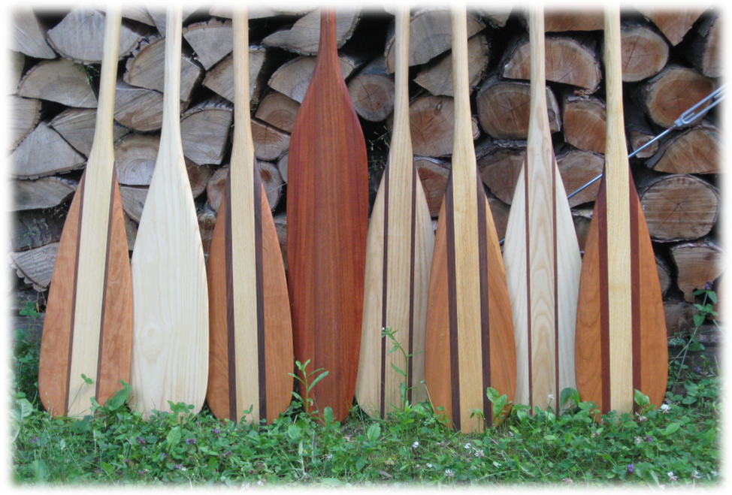**HANDCRAFTED CANOE PADDLES**

**EAST ROAD TINMOUTH**

**802-446-2228**

**Great Gifts!!**

**LCS BUILDERS**

**20 Bliss Road**

**Tinmouth, VT 05773**

**(802) 446-2728**

[**lcsbuilders@vermontel.net**](mailto:lcsbuilders@vermontel.net)

**New Construction Fine Cabinetry**

**Renovations Millwork**



**Pet care available,**

**very reliable 10 year old.**

**Dog walking, etc.**

**Jimmy Barrett 446-3986**

**references available.**









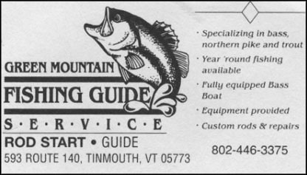

www.greenmountain.com



**NOBLE ACE HARDWARE**

261 NORTH MAIN STREET

RUTLAND, VT 05701

(802) 773-2758

OPEN: 7:00 AM – 8:00 PM MON.-FRI.

7:00 AM – 7:00 PM SAT.

8:00 AM – 5:00 PM SUN

**HARDWARE WITH A HOMETOWN FEELING**



**Doug Fontein**

**Tinmouth Channel Construction**

143 Channel Road

Tinmouth, VT 05773

(802) 446-2928 phone

(802) 446-2930 fax

[eworks@vermontel.net](mailto:eworks@vermontel.net)

***energy efficient custom built homes and additions***



**FAMILY HISTORY SEARCH**

Do you know your grandmother’s maiden name?

Or what your great grandfather did for a living?

Who were you ‘Immigrant Ancestors’?

I may be able to help you find answers to questions like these.

I have fifteen years experience in genealogical research and a huge curiosity about our ancestors.

Reasonable rates. Free initial consultation.

Call me to set up a time.

Gene Usher Tinmouth, VT

Phone 446-2228 or Email [genieusher@gmail.com](mailto:genieusher@gmail.com)





**Land For Sale** at 567 East Road, Tinmouth, VT 10.7 Acres

Asking $58,300

**Please call 508.943.1754**



Contact us for a FREE on-site consultation for your kitchen or bath remodel project.

**Work Wanted:** Companion sitting, light house work, child care, dog walking, feeding animals, running errands, taking you to a medical appointment. **Carol Bohlin**, **446-2119**

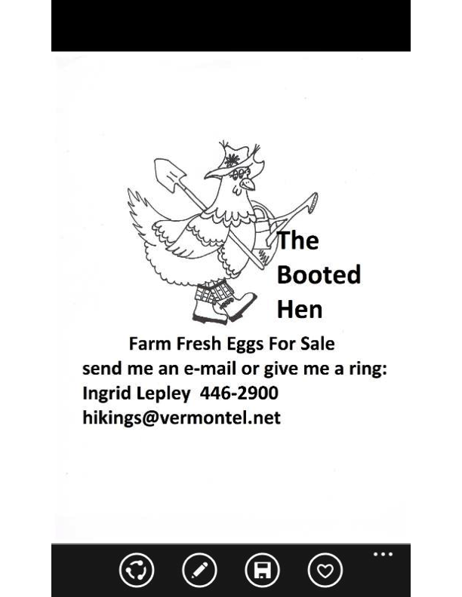



**For Sale: 6’ York Rake**

**3 point hitch, with wheels**

**good condition.**

**$700**

**Call Rick at 802-446-2870**



**Cottage for Sale**

We are selling our lovingly restored cottage at the end of West Shore Drive, # 100 (some may still know it as the Gilmore place).

It has been totally renovated in the past 6 years, so it is new from the inside out.

2 bedrooms, open kitchen/ living area, large bathroom with electric baseboard heat, propane heater for the main living area, electric stove. All appliances are new within the last 5 years.

It is being sold furnished, so this means you could simply walk in and start to enjoy!

Check us out on Facebook  “Made in the Shade Tinmouth, Vt”

If interested, or know someone who is interested, please contact Barbara  or Rob at 802.558.7395, 516.509.7663 or message us on  the FB page.

**Kripalu Flow Yoga**

**Wednesday Evenings**

**5:30 – 7:00 pm**

**At the Community Center**  “*Stretch away muscle tension, breathe deeper, let go.”*

Kripalu certified yoga instructor, Bess Lewis,

 leads rejuvenating and deeply relaxing flow sequences.

Come give yoga a try in a warm inviting yoga community!

Experience improved strength and flexibility.

 besszephyr@yahoo.com



~ South School circa 1946 ~

Back row Anna Edmunds, Clifton Phillips, teacher Lillian Gilmore, Glenn W. Merrill, Harold Edmunds

Front row Mildred Merrill, Winifred Merrill, Ralph Merrill, Helen Phillips, George Nesbitt, Dorothy Bushee



