Tinmouth Community Fund awards College Scholarships

The Tinmouth Community Fund awarded $10,500 in scholarships to Tinmouth students on Monday June 19 at the Old Firehouse. The scholarships were awarded based on a combination of potential, merit and financial need.

Our 9 recipients in 2017 are:
- Theresa Butts, a senior at Castleton studying Biology and pursuing an advanced degree to be a Physician’s Assistant
- Katy Czar, a junior at UVM studying Physics
- Alex Dixon, a senior at St. Mike’s studying Accounting
- Kayla Durant, a junior at Castleton studying Biology and planning to become a veterinarian
- Megan Fox, a senior at UVM studying Nursing
- Mark Goyette, a senior at Clarkson studying Mechanical Engineering
- Ellie Hasenohr, a junior at UVM studying Biology
- Chelsey Keyes, a senior at Vermont Tech studying Fire Science
- Seamus Nauton, a freshman at Wentworth Institute of Technology studying Computer Science

The Scholarship Committee thanks the Town of Tinmouth for their donation of 25 percent of the Tax Stabilization Fund, the Tinmouth Plant Sale and generous individual donors for their support. We continue to desire to grow this fund to insure its perpetuity Feel free to call or email Cathy Reynolds with any questions at 446-2928 or eworks@vermontel.net or speak to any Scholarship Committee Member.

Tinmouth Scholarship Committee: Ruth Drachman, Nelson Jaquay, Bob Lloyd, Denise McGinley, Caleb Scott, Rene Wilbur, Annie Robbins, Asha Carroll, Jan Krantz.

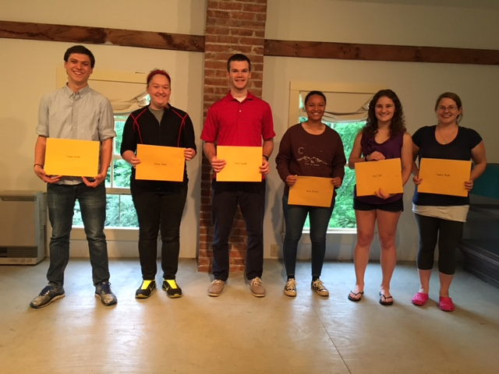
2017 Scholarship Recipients - Seamus Nauton, Chelsey Keyes, Mark Goyette, Kayla Durant, Katy Czar, Theresa Butts – not pictured Ellie Hasenohr, Megan Fox and Alex Dixon

